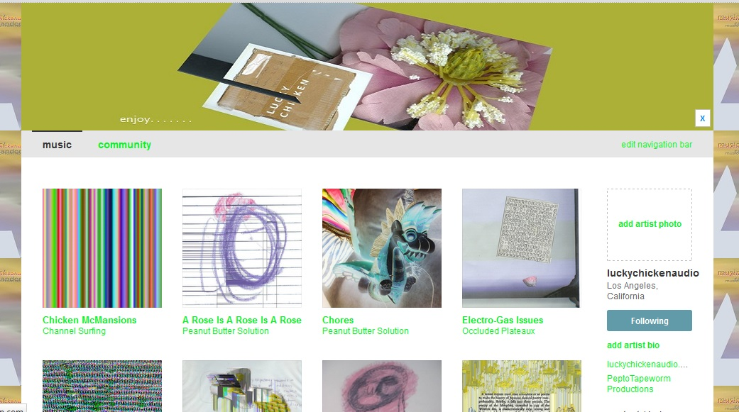

The hierarchy is mainly based around two things. . . The logo at the top is the focal point, and the albums, with included images make up the body of the page. . . it also has a background image that contrasts with the album covers.

For this project, there will be six albums across the page. . . The enclosed image is based on my bandcamp page. . . So the idea is to create an html version of my bandcamp page, but with a little different layout, based on the html. . . I will try to make this easy for you.

There will be contact info off to the right side of the page. And nearly all aspects of the page will redirect to the main page, by clicking on the logo

. This is the logo image.

This is the background image that spans across the page. 

